Name: James Young  
Date: Dec 10, 2019

Magpie Chatbot Lab

**Directions**: Make note of your responses to the following questions as you work through activities 1, 2, and 3 of the AP Computer Science Lab: Magpie.

# Activity 1

1. Which chatbot did you use?

I used Chomsky.

1. Paste your conversation with the chatbot below.

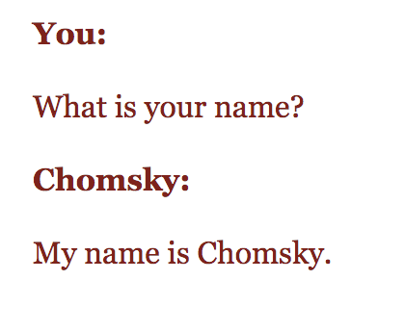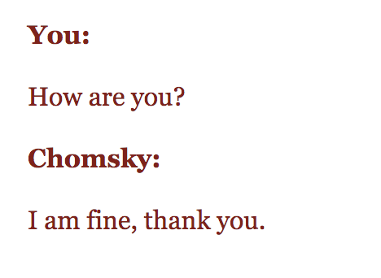

1. What was the most interesting or peculiar response? Why?

When I asked what time it was, it responded with: “In Cambridge where I am, the time is: 02:29:12 AM.” This was peculiar to me as it managed to get a very precise time that was accurate to real life.

1. Think about your conversation with a chatbot. Identify key words to which you think the chatbot responds.

There are many key words, such as: “name”, “time”, “date”, “hi”, “weather”, “how are you”, and so on.

1. Suggest several key words and the possible corresponding responses.

For the key word “weather”, the chatbot could respond with a random weather. For the key word “how are you”, the chatbot can respond with great.

# Activity 2

1. What happens when a key word is included in another word? Consider statements like "I know all the state capitals" and "I like vegetables smothered in cheese." Explain the problem with the responses.

Because the chatbot has two different automated responses for the different key words, it therefore has a problem deciding which response is appropriate as it is just looking for key words but doesn’t understand the question itself so it has two automated responses in conflict.

1. The lab suggests using the trim method from the String class. How does it work? Show an example of a String value before and after the trim method is invoked.

The method returns a copy of the string, with leading and trailing whitespace omitted.

Ex:

class Gfg {

public static void main(String args[]) {

String s = " geeks for geeks has all java functions to read ";

System.out.println(s.trim());

}

}

Without s.trim, s would print " geeks for geeks has all java functions to read ". With trim, s.trim prints “geeks for geeks has all java functions to read".

1. Paste the code below showing the additional two noncommittal responses added to getRandomResponse.

else if (whichResponse == 4)

{

response = "That's pretty cool, please tell me more.";

}

else if (whichResponse == 5)

{

response = "I don't quite understand that, but that seems cool.";

}

1. Complete the table below. List the additional keywords and responses you added to the getResponse method.

| Keyword | Response |
| --- | --- |
| weather | It seems sunny and warm outside. |
| School | Tell me more about your school. |
| You | I’m just a chatbox, there’s nothing interesting about me. Tell me more about you. |

1. What happens when more than one keyword appears in a string? Consider the string "My mother has a dog but no cat." Explain how to prioritize responses in the reply method. Did this impact any changes you made to the getResponse method?

If more than one keyword appears, the program will output the response corresponding to the first keyword.

# Activity 3

Trace through the following method calls. Write the value of the variables position, before, and after each time the program control reaches the point in the method indicated by the comment.

1. findKeyword( "She’s my sister", "sister", 0);

| Iteration | position | before | after |
| --- | --- | --- | --- |
| 1 | 9 | “ “ |  |

1. findKeyword( "Brother Tom is helpful", "brother", 0);

| Iteration | position | before | after |
| --- | --- | --- | --- |
| 1 | 0 |  | “ “ |

1. findKeyword( "I can’t catch wild cats.", "cat", 0);

| Iteration | position | before | after |
| --- | --- | --- | --- |
| 1 | 8 | “ “ | c |
| 2 | 19 | “ “ | s |

1. findKeyword( "I know nothing about snow plows.", "no", 0);

| Iteration | position | before | after |
| --- | --- | --- | --- |
| 1 | 3 | k | w |
| 2 | 7 | “ “ | t |
| 3 | 22 | s | w |
|  |  |  |  |

1. Your choice. Fill in the parameters and then trace the method call.  
   findKeyword( "Go and be good", "go", 0 );

| Iteration | position | before | after |
| --- | --- | --- | --- |
| 1 | 0 |  | “ “ |
| 2 | 10 | “ “ |  |